1. artificial and biological neurons

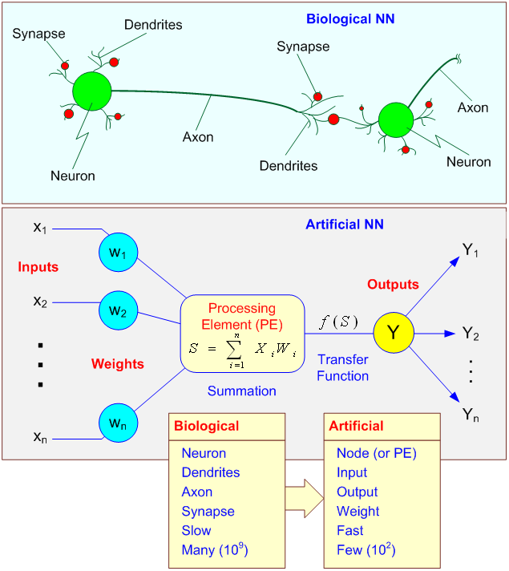

1. SOM for segmentation – how

$s$ = Current iteration

$λ$ = Iteration limit

$t$ = Selected index of input vector from input set D

$D(t)$ = Selected input vector

$v$ = Current index of node in the map

$W_{v}$ = Current weight vector of node $v$

$u$ = Index of best matching unit (BMU)

$θ\left(u,v,s\right)$ = Restraint due to distance from BMU, usually called the neighborhood function

$α\left(s\right)$ = Learning restraint due to iteration progress

1. Randomize the node weight vectors in a map
2. Randomly pick an input vector {\displaystyle {D}(t)}
3. Traverse each node in the map
   1. Use the Euclidean distance formula to find the similarity between the input vector and the map's node's weight vector
   2. Track the node that produces the smallest distance (this node is the best matching unit, BMU)
4. Update the weight vectors of the nodes in the neighbourhood of the BMU (including the BMU itself) by pulling them closer to the input vector

*{\displaystyle W_{v}(s+1)=W_{v}(s)+\theta (u,v,s)\cdot \alpha (s)\cdot (D(t)-W_{v}(s))}*

1. Increase *a* and repeat from step 2 while {\displaystyle s<\lambda }
2. supervised and unsupervised networks - application, advantages, limitation

|  |  |  |
| --- | --- | --- |
| Category | Supervised | Unsupervised |
| Application | OCR  Spam detection | Data mining  Image segmentation  Anomaly detection |
| Advantages | Can specify how many classes of output  Can be very specific on the definition of classes  Trained network is more accurate | No need to label dataset  Less complexity  Able to discover pattern that might not be clear to human |
| Limitation | Overfitting  Need to label dataset  Training takes a lot of computation time | Trained network is less accurate  Cannot get very specific on definition of classes  Results of analysis cannot be ascertained |

1. MLP and BP - architecture, backpropagation pseudocode, advantages 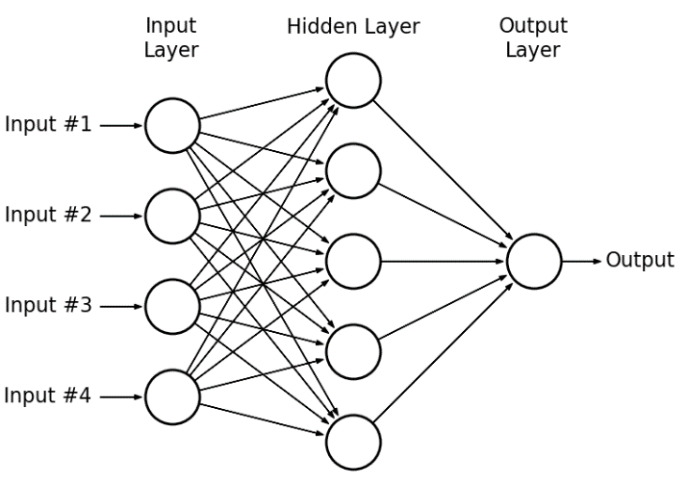

Multilayer Perceptron (MLP) = Multiple layer of perceptron

Why?

* Perceptron cannot handle simple non-linearly separable problem (XOR problem)
* Parallel processing between layers

Backpropagation (BP) pseudocode

* Init network weights
* Phase 1: Propagation
  + input propagate forward through the network to generate output
  + calculate the cost / error term
  + output activations propagate backward through the network using training pattern target to generate delta (target – output) of all output and hidden neuron
* Phase 2: Weight update
  + compute gradient of the weight by multiplying output delta with input activation
  + update weight adverse to gradient by subtracting a ratio (learning rate) of weight

initialize network weights

do

foreach training sample as x

let output = neural_net_output(x)

let target = x.label

let error = target-output

compute delta-weight = error * x.input for all nodes

update weights

until all training sample classified correctly or stopping criteria met

return network-trained

1. Reinforcement Learning - diagram, explain components, advantages, application

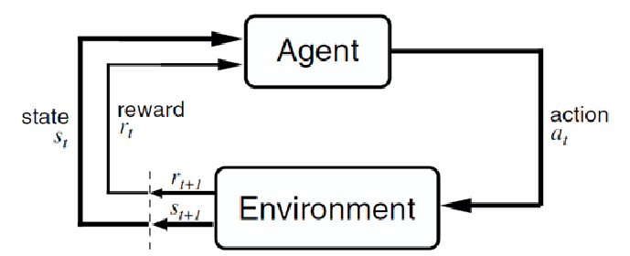

Markov Decision Process (MDP)

$$(S,A,P_{a},R_{a},γ)$$

$S$ = Finite set of states

$A$ = Finite set of actions (available from state $s$)

$t$ = Time frame

$P_{a}$ = Probability of transition from state s to *s’* under action *a*

$R_{a}$ = Immediate reward after action *a*

$γ$ = [0,1], Discount factor

Agent = Take action on the environment with aim to get highest reward

Environment = Returns state and reward to agent based on action taken

Advantages

* Balancing exploration vs exploitation
* Exploration = Exploring uncharted territory, find new action that have best long-term reward
* Exploitation = Exploiting current knowledge, generate output based on training dataset

Application

* Playing games
* Abstract text summarization